Question ist=[{product_id:321,barcode_id:123,product_name:'vnfdhdh',volume:2.0,price:50.0,barcoded:null,
primaryCategory:{category_id:1,category_name:'fruits'}},
{product_id:321,barcode_id:123,product_name:'vnfdhdh',volume:2.0,price:50.0,barcoded:null,
primaryCategory:{category_id:1,category_name:'fruits'},}
];

Solution 1

var list=[{product_id:321,barcode_id:123,product_name:'vnfdhdh',volume:2.0,price:50.0,barcoded:null,
primaryCategory:{category_id:1,category_name:'fruits'}},
{product_id:321,barcode_id:123,product_name:'vnfdhdh',volume:2.0,price:50.0,barcoded:null,
primaryCategory:{category_id:1,category_name:'fruits'},}
];

var obj2 =list.map((item,index) =>{
return{
...item,
...item.primaryCategory,}

})
console.log(obj2);

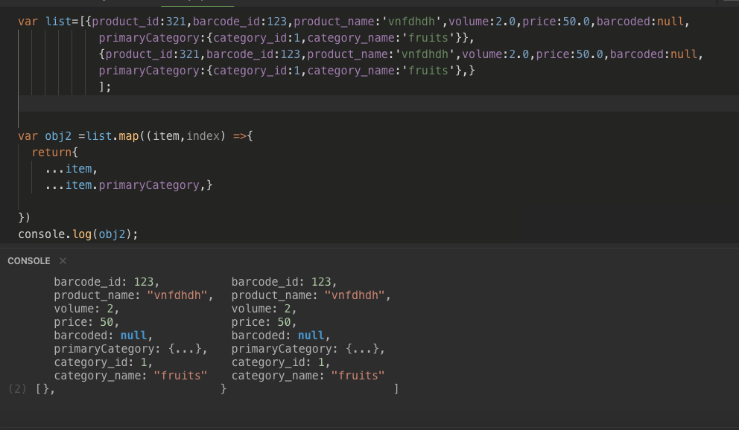

Solution 2

var list=[{product_id:321,barcode_id:123,product_name:'vnfdhdh',volume:2.0,price:50.0,barcoded:null,
primaryCategory:{category_id:1,category_name:'fruits'}},
{product_id:321,barcode_id:123,product_name:'vnfdhdh',volume:2.0,price:50.0,barcoded:null,
primaryCategory:{category_id:1,category_name:'fruits'},}
];

var obj2 =list.map((item,index) =>{
return{
...item,
...item.primaryCategory,}

})

obj2.map((x,key)=>{
// console.log(key);
delete x.primaryCategory;
})

console.log(obj2
);

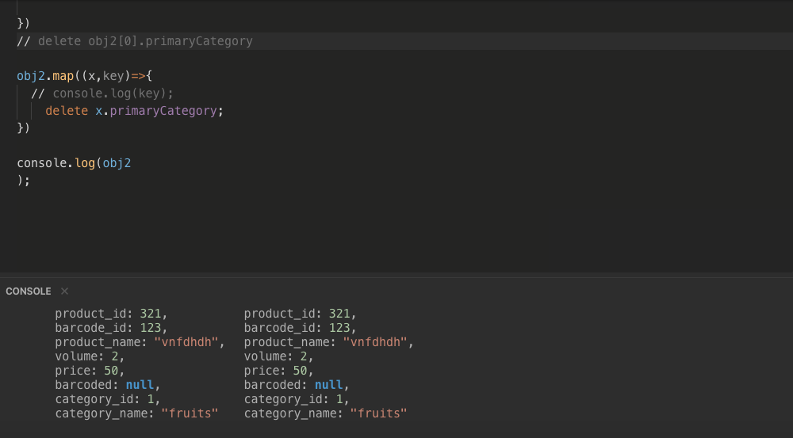

Solution 3
var list=[{product_id:321,barcode_id:123,product_name:'vnfdhdh',volume:2.0,price:50.0,barcoded:null,
primaryCategory:{category_id:1,category_name:'fruits'}},
{product_id:321,barcode_id:123,product_name:'vnfdhdh',volume:2.0,price:50.0,barcoded:null,
primaryCategory:{category_id:1,category_name:'fruits'},}
];

var obj2 =list.map((item,index) =>{
return{
...item,
...item.primaryCategory,}

})
delete obj2[0].primaryCategory
delete obj2[1].primaryCategory

// obj2.map((x,key)=>{
// // console.log(key);
// delete x.primaryCategory;
// })

console.log(obj2);

